Erick Cabrera

Mortgage Exercise

ITM 311-02

1. Use the Scanner class for input
2. Declare a class MonthlyMortgage
3. Call main to calculate (either sequentially or through a method)
4. Declare local variables: loanAmt, term, rate, pmt
5. Output statements to ask the user for the variable values
6. Input statements for the local variables
7. Processing statement -> use the formula
8. Output statement that will give the payment
9. While loop to ask the user-> run the program again

Code

import java.util.Scanner;

public class MonthlyMortgage

{

static Scanner sc = new Scanner(System.in);

public static void main(String args[ ])

{

//declare the local variables and initialize them

double purchasePrice = 0.0;

double perCentDP = 0.0;

double loanAmt = 0.0;

double rate = 0.0;

double pmt = 0.0;

int term = 0;

char answer ='Y';

while (answer == 'Y' | answer == 'y'){

System.out.println("Hello! Please insert your purchase price: ");

purchasePrice = sc.nextDouble();

System.out.println("Now insert your down payment percent: ");

perCentDP = sc.nextDouble();

System.out.println("Next, insert your term in years: ");

term = sc.nextInt();

System.out.println("Almost done! We just need your interest rate: ");

rate = sc.nextDouble();

System.out.println("Lastly, insert your loan amount: ");

loanAmt = sc.nextDouble();

pmt = loanAmt \* (rate/12) / (1 - Math.pow(1 + rate/12, -term\*12));

System.out.println("Based off your information, your monthly mortgage payment is: " +

"\n" + pmt);

System.out.println("Would you like to calculate another mortgage?");

System.out.println("Y = yes, N = no");

answer = sc.next().charAt(0);

}

}

}

Output

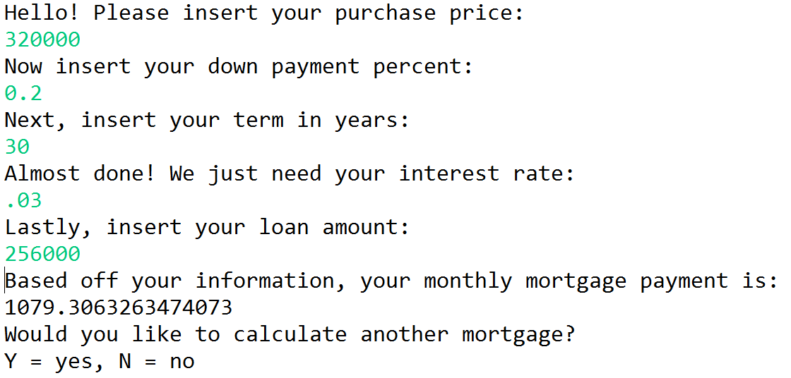

Excel Spreadsheet

